# 

# Everything you need to know about *proving* limits:

So the formal definition of limits is weird. It’s forcing an intuitive concept into a “predicate logic paradigm”. But you need to know this for your final exam so let’s do this! First, knowing you, you remember the khan academy video on this well enough. If not, watch it.

Now, let’s start with the formal definition of a limit for MAT137:

$$if f\left(a,b\right)→R and c∈\left(a,b\right)$$

$$we say that \lim_{x→c}{f\left(x\right)=L}$$

$$AND$$

$$∀ϵ>0, ∃ δ s.t. 0<\left|x-c\right|<δ → \left|f\left(x\right)-L\right|<ϵ$$

Before I get into the intuitions of this, here’s a visual of $\lim_{x→1.6}{x^{2}}$ with this formula. I chose some epsilon bands[1] (explain this soon), and found a delta band that fits (technically, I should’ve made it +/- from 1.6^2, but visual clarity wins here).

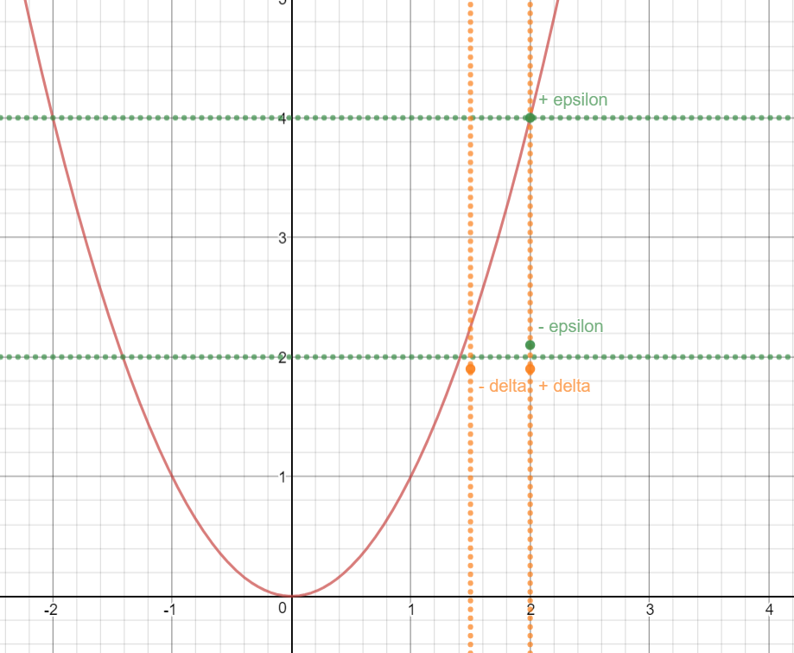

Notice:

* how the notion of a band is translated into abs. val. In the algebraic definition. So that you could do $± \left(x-c\right)∧\left(f\left(x\right)-L\right)$. For the delta band, you could also write

$$delta band=x∈(c- δ, c+ δ)$$

This will be useful for more complicated limits.

* That we first choose an epsilon band, then choose the delta band to fit inside the delta band (*For all* epsilon, there *exists* a delta s.t. …)

No matter what epsilon band I choose, I will be able to find a delta band that will fit inside there \***IF\*** the limit exists. So for example:

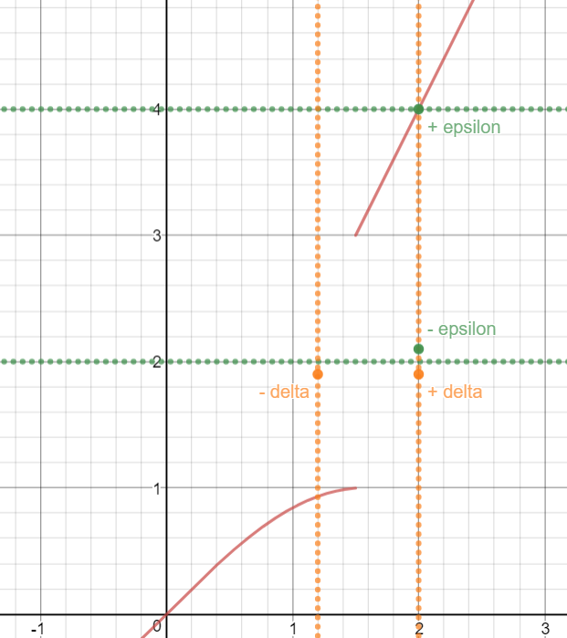

This function doesn’t have any limit at x = 1.5. Notice that we just broke the predicate logic definition here. Since we could choose any epsilon range we want (and all of them must be permitted bc of the $∀ ϵ$), and there must exist a delta range where all points in the delta range are in the epsilon range. Notice that there ALWAYS be some points outside an epsilon range no matter how small we make delta (and by the definition, the delta band cannot be zero). Mathematically, this could be understood as breaking the $\left|f\left(x\right)-L\right|<ϵ$, since f(x) – L will be GREATER than epsilon.

* It could also happen that you choose a bad delta band, for example:

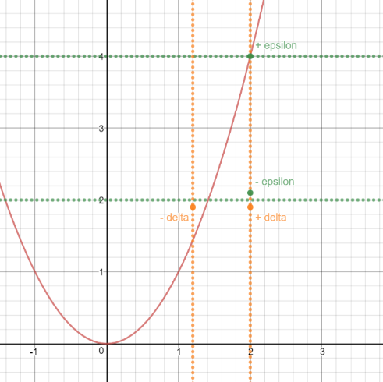

This graph has a delta band that has broken the rule, since some points are in delta, but NOT in epsilon. Notice that in the first graph, there are points that are in epsilon but not in delta. That’s fine: if we look at the proof, x-c < than delta implies f(x)-L < than epsilon, meaning that it’s a one way thing.[2]

Now, a couple of things to notice:

* Don’t confound the lim(x->c) f(x) = L with the definition of a continuous function, which is defined as

$$\lim_{x→c}{f\left(x\right)=f\left(c\right)}$$

Which I think you’re smart enough to see this is self-evident.

p.s this is represented in the epsilon-delta definition by going from “0 < x-c <delta” into x-c <delta (no more 0<)

* So the obvious meaning of a limit is that as x becomes arbitrarily small, we converge on L. In predicate logic, this is shown with the $∀ ϵ$ and $\left|f\left(x\right)-L\right|<ϵ$, since epsilon MUST be able to get arbitrarily small. THIS is the key to getting arbitrarily close to the desired part of the function.
* Delta is dependent of epsilon, since you first choose epsilon (comes first in the predicate definition). This will come in handy later
* If your representing the band with algebra on the graph, you must use open set notation i.e. (x-delta, x+delta) interval, due to the delta being strictly less than the equation when putting it on the graph
* We’re NOT finding the limit, we’re proving the limit. This is different, since in most of these cases, the limit will be given.
* For the delta inequality, it starts with a $0<…$, while the epsilon inequality doesn’t. This is because we want to reach where F(x) -L = 0 to not have a *single* solution. Also, f(c) doesn`t need to equal L, since L is a value we chose. it’s legitimate to say f(x) – L since L is not dependent on f(x).
* (for variations of the definition, and the results they give, see assignment two answers).
* You’ll notice that the combo $∀a, ∃b…$ will almost always make you boil down to choosing a b in function of a

$$b\left(a\right)=2a$$

This is normal, as you want evey b to fit with the parameters of a.

## Going through a proof of a limit:

There is a lot of weird steps here, since the predicate logic/proof paradigm we’re using here is un-intuitive at first glance. I’ll explain every step of the way what is happening to these following proofs for you (me!) to get a good understanding. First, you must establish the goal: you must get f(x)-L be less than epsilon, since this is not a given. Since epsilon can be arbitrarily small, it is the ‘converging to’ part of your equation. In mathematical practice, this means that $\left|f\left(x\right)-L\right|<ϵ$,as it follows from the definition of a limit.

$$\lim_{x→3}{4x+1=13}$$

First, establish the fact you know by looking at the definition:

$$0< \left|x-c\right|= \left|x-3\right|<δ$$

Through this fact, you want it to imply:

$$\left|f\left(x\right)-L\right|= \left|(4x+1)-13\right|<ϵ$$

You want to imply that because the goal is to get this equation could be less than epsilon. This process of finding such an inequality is called “ [Rough work] ”, and should be indicated at the beginning of the paper.

To show this implication is possible, you start off with “ f(x) – L ” and work your way towards the first equation[3]. You are NOT allowed to change the ultimate value of the function; you must massage it by multiplying by 1, or adding 0, or combining/disjointing terms:

$$=\left|\left(4x+1\right)-13\right|$$

$$=\left|4x-12\right|$$

$$=4\left|x-3\right|$$

(you’re allowed to factor out # from abs. vals.)

Now you got yourself to a familiar equation: you got $\left|x-3\right|$. You could replace this by delta. Why could you do that? Because this follows the definition of a limit. However, it will not always be so easy to replace delta, I’ll prove why we could replace by delta for every linear equation, and later show why this isn’t always the case. Recall that:

$$x∈\left(3-δ, 3+ δ\right)$$

$$⇔$$

$$\left|x-3\right|< δ$$

$$⇔$$

$$-δ< x-3<+ δ$$

$$⇔$$

$$3-δ< x<3+ δ$$

All these are logically equivalent to each other. When you replace the equation with delta, you use the 2nd equation. This is not possible with many equations, and we need to use the 4th equation. For demonstration purposes, we’ll proceed with the 4th equation. We want to choose the part of the equation that will flip the sign in the desired manner, explained in a moment.

$$x<3+ δ$$

$$x-3<δ$$

We can know replace that into the equation. The abs of delta will be positive, so we can get rid of the absolute value.

$$<4δ$$

This will happen for every **linear** equation, therefor simply replacing by delta is sufficient.

Notice that the equality switched to an inequality. This is part of the definition, since $\left|x-3\right|<δ$. This is also crucial to the end goal, that being f(x)- L < epsilon. So how do we continue to get to epsilon? First, remember that delta is defined as follows

$$∀ϵ, ∃δ…$$

This statement implies an important rule in the proof paradigm:

Since delta is dependent on epsilon, any epsilon band I choose, delta should be able to automatically adjust to fits the idea of “for all epsilon, there exists a delta s.t. …”. Therefore -> $δ(ϵ)$. This means I can choose my delta to be what I want in respect to epsilon, since I want a delta range to exist for any epsilon I choose. It will not happen that a delta band has x points where outside the epsilon band when using this method.

Since delta could be a function of epsilon, and we could make delta what we want[4], it is legitimate to replace delta with a function of epsilon that will get rid of the 4 in front. So, for our example, let $δ=\frac{ϵ}{4}$

$$<4\frac{ϵ}{4}=ϵ$$

Graphically, this means that is we choose a epsilon range of $±2$, delta should be $±0.5$.

Now you’ve got a chain of logic that brings you from f(x)-L … < … $ϵ$. You can now formally prove the limit exists. To get 100% on your test, follow these steps:

1. For some reason, I must specify $ϵ>0$ instead of referencing the definition of a limit. So:

Let $ϵ>0$ be given

1. You must set your $δ$. Since you must find that a delta exists for all epsilons, you should set delta to be a function of epsilon. Through your rough work, you figured out the optimal value of $δ$ that will bring you to your goal

Set $δ=\frac{ϵ}{4}$

1. You can now choose many methods, but the most common and the one followed for this proof is the one starting with $\left|f\left(x\right)-L\right|$.
$$\left|f\left(x\right)-L\right|= \left|4x+1-13\right|$$

$$= \left|4x-12\right|$$

$$= 4\left|x-3\right|$$

2. Through the definition of limit, you’re allowed to replace x-3 by delta. Remember that this is because delta is a linear equation:
$$< 4δ$$

3. Now you could replace delta with epsilon…

$$<4\frac{ϵ}{4}=ϵ$$

You know have an inequality saying that $\left|f\left(x\right)-L\right|<ϵ∴Q.E.D.$

Now let’s write this 100% properly:

Let $ϵ>0$ be given, and $δ=\frac{ϵ}{4}$

Assume $0< \left|x-3\right|<δ=\frac{ϵ}{4}$

$$\left|f\left(x\right)-L\right|= \left|\left(4x+1\right)-13\right|$$

$$= \left|4x-12\right|$$

$$=4\left|x-3\right|$$

We now replace $\left|x-3\right|$ by $\frac{ϵ}{4}$

$$<4\left(\frac{ϵ}{4}\right)=ϵ∴Q.E.D.$$

## Proof a limit with a bound:

Now let’s proof a non-linear one:

$$\lim_{x→5}{x^{2}+2}=27$$

Remember, first we establish the fact you know by looking at the definition:

$$0< \left|x-c\right|= \left|x-5\right|<δ$$

Through this fact, you want it to imply:

$$\left|f\left(x\right)-L\right|= \left|(x^{2}+2)-27\right|<ϵ$$

Now let’s start with the implied statement and try to find were we could replace delta and then be able to get an epsilon in here. Starting with the later equation:

$$= \left|(x^{2}+2)-27\right|$$

$$= \left|x^{2}-25\right|$$

$$= \left|x+5\right|\left|x-5\right|$$

We now have $\left|x-5\right|$, so we can replace it with delta and change the symbol[5]

Last time we got here, we had a constant in front of the delta. This time, we have a function based on x. No ‘x-5’ appear in our proof, so what we’ll do to get rid of it is something called bounding. What this means is that we’ll find the largest possible value this function could attain by choose a delta range. We must choose a delta range to determine what’s the largest value the rest of the function will have. The purpose for the max value is so that if the resulting equation works, any smaller value of delta should also work. This is a consequence of the definition. For example, let delta be +/- 1 from the limit:

$$before choosing delta: x∈(5-δ, 5+δ)$$

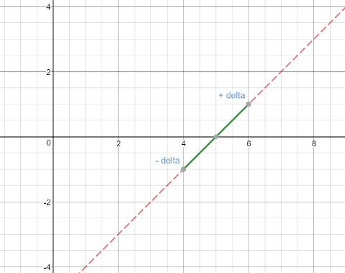

$$after choosing delta:x∈(5-1, 5+1)$$

This means that the max value would be 1. Notice that we’re not looking at the max value of x. all we care about with x is that it doesn’t explode f(x) if we plug in a value in the range. For example, if the range was $x∈(-1,3)$ and the function was $\frac{1}{x}$, then $\frac{1}{0}$ would be a problem. In that scenario, you choose a different bound. We can know work towards” $\left|x+5\right|$” and see what’s the max value that function Will achieve.

Résumé:

* That we’re choosing a value for delta and then figuring out the value of the bound. We can choose any delta as long as the following delta band doesn’t do anything weird, i.e. no discontinuities or asymptotes. Let’s say you’re trying to bound 1/x. You don’t want this to happen:

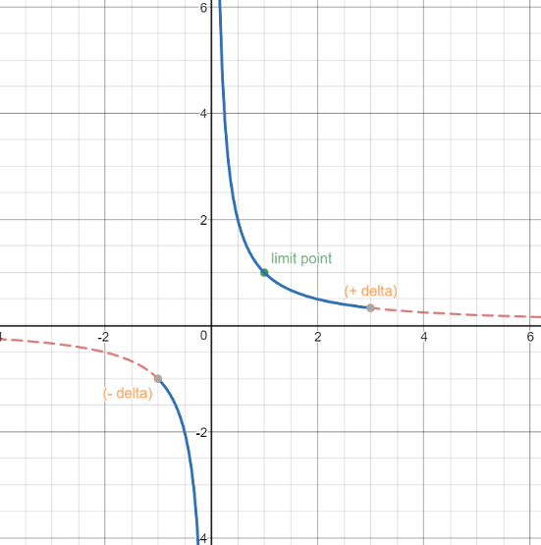

$$x∈(1+2, 1-2)$$

No epsilon band exists where that happens[6], so we cannot let a delta range in this fashion.

* That for any non-linear function, a bounding will need to occur. For example (x-pi)sin(x), where (x-pi) will be replaced by delta. Sin(x) will need to be bounded.
* That you could think about the maximum value as the delta band getting as close as possible to the epsilon band without breaking the definition.

For this function, we decided that:

$$δ<1$$

$$\left|x-5\right|<1$$

From this we do some manipulations towards our bound.

$$\left|x-5\right|<1$$

$$-1<x-5<1$$

$$9<x+5<11$$

$\left|x+5\right|<11$

*

With this in mind, we can know replace abs(x+5) with 11. Remember that this is the rough work, and when actually proving the limit, you’d want to be able to bring this up quickly. The most efficient way of doing this is by labeling this bound with *, like I’ve done above

$< 11δ$

Following the logic from the previous proof, we’ll define delta in terms of epsilon. We’ll label this ** to be able to reference it in the actual proof.

$δ=\frac{ϵ}{11}$

$$<\frac{11ϵ}{11}=ϵ$$

**

Now for the formal proof:

Let $ϵ>0$ be given. Set delta to be the [7]

Assume $0< \left|x-5\right|<δ$

$$= \left|f\left(x\right)-L\right|$$

$$= \left|x^{2}+2-27\right|$$

$$=\left|x^{2}-25\right|$$

$$= \left|x+5\right|\left|x-5\right|$$

By assumption we get

$$< \left|x+5\right|δ$$

By * we get

$$<11δ$$

By ** we get

$$<\frac{11ϵ}{11}=ϵ Q.E.D.$$

## Hard limits

We’re going to do two hard limits:

$$\lim_{x→\frac{1}{20}}{\frac{1}{x}=20}$$

And the

$$thomae function$$

Starting with the former, we’ll start with what we know and work are way towards the answer:

We have

$$= \left|\frac{1}{x}-20\right|$$

And we and to go towards a function where delta could be swapped in, i.e.:

$$\left|x-\frac{1}{20}\right|$$

For this exercise, it is useful to bring back a previously explored concept of the delta band:

$$delta band=\left(c- δ, c+δ\right)$$

$$delta band=x∈\left(\frac{1}{20}-δ,\frac{1}{20}+δ\right)$$

This concept should be brought up when dealing with non-linear bounds and deltas.

Start:

$$= \left|\frac{1}{x}-20\right|$$

$$=\frac{20}{\left|x\right|}\left|\frac{1}{20}-x\right|$$

Which is equivalent to:

$$=\frac{20}{\left|x\right|}\left|x-\frac{1}{20}\right|$$

Bc of the abs. val.

We can simply replace delta because it’s linear, so no special manipulation is needed. However, just to show what’s going on behind the scene:

$$x∈\left(\frac{1}{20}-δ,\frac{1}{20}+δ\right)$$

$$⇔$$

$$\frac{1}{20}-δ<x<\frac{1}{20}+δ$$

$$x-\frac{1}{20}<δ$$

$$<\frac{20}{\left|x\right|}δ$$

Now bound. Note that we cannot set x to be +/- 1 because it diverges to +/- infinity. Looking at these graphs,

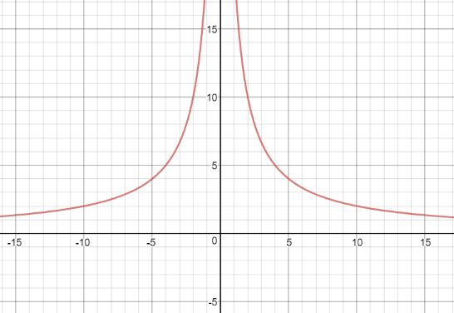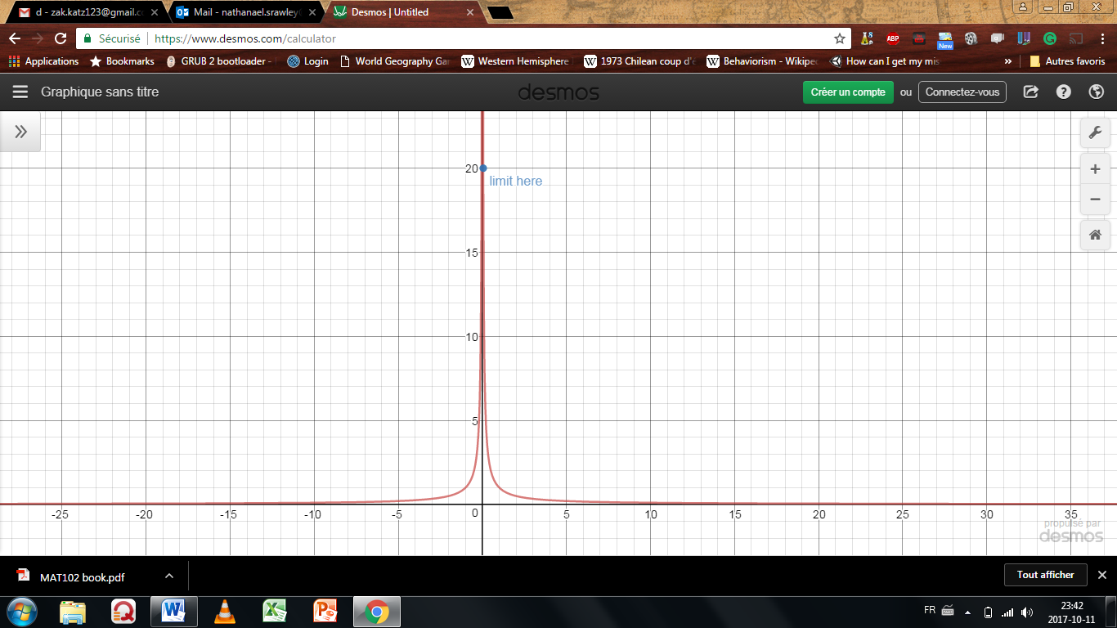

One must choose delta very carefully, less we diverge towards infinity.

$$x∈\left(\frac{1}{20}-δ,\frac{1}{20}+δ\right)$$

In this case, I’ll choose the delta range to be $±\frac{1}{40}$,since the function won’t explode. The function is injective on the range we took, thus either the maximum or minimum value of x will produce the maximum value of our function. Notice the largest delta won’t always be the largest value of the bound.

$$δ≤\frac{1}{40}$$

I set delta to be $≤$ to the function so that delta could shrink and become arbitrarily small.

$$x∈\left(\frac{1}{20}-\frac{1}{40},\frac{1}{20}+\frac{1}{40}\right)$$

$$x∈\left(\frac{1}{40},\frac{3}{40}\right)$$

In this case, it’s the small x that produces the largest value for the bound:

$$\left|x-\frac{1}{20}\right|<\frac{1}{40}$$

$$-\frac{1}{40}<x-\frac{1}{20}<\frac{1}{40}$$

$$\frac{1}{20}<x<\frac{3}{40}$$

$$\frac{1}{400}<\frac{x}{20}<\frac{3}{800}$$

$$400>\frac{20}{x}>\frac{800}{3}$$

$$\left|\frac{20}{x}\right|<400$$

$$<400δ$$

Now simply set $δ=\frac{ε}{400}$, and complete the proof formally.

$$THOMAE FUNCTION:$$

Now we’ll find the limit for this function:

$$f\left(x\right)= \left\{ \begin{aligned}\frac{1}{q} if x=\frac{p}{q} \left(x is rational\right), with p∈Z and q∈N and GCD\left(p,q\right)=1 \\ 0 if x is irrational \end{aligned}\right\}$$

## One-sided limit:

Very similar, here’s the difference:

$$∀ϵ>0, ∃δ>0, s.t. x∈\left(c, c+δ\right)⇒\left|f\left(x\right)-L\right|<ϵ$$

You’re know taking one side of the limit. Ex:

$$\lim_{x→1^{+}}{\sqrt{x-1}=0}$$

This time, I’ll show two ways’ of solving it. The earlier method, and a new one. First the earlier:

$$=\left|\sqrt{x-1}\right|$$

The absolute value could be dropped because the function is strictly positive

$$=\sqrt{x-1}$$

$$<\sqrt{δ}$$

Let $δ=ϵ^{2}$

$$<ϵ Q.E.D.$$

The second method could come in useful if you make a mistake or see it is easier to work backwards. It’s usually easier when we’re doing manipulations on one x. Start with delta and work our way towards an epsilon.

1. Start with the delta band:
$$x∈\left(1,1+δ\right)$$

$$1<x<1+δ$$

2. Get x to equal f(x)
$$0<x-1<δ$$

$$0<\sqrt{x-1}<\sqrt{δ}$$

3. Set epsilon equal to delta and reverse the function till you get delta equal to a function of epsilon:
$$\sqrt{δ}=ϵ$$

$$δ= ϵ^{2}$$

4. Plug back into the formula (and since $\sqrt{x-1}$ is strictly positive. No need to add back in the absolute value)

$$0<\sqrt{x-1}<\sqrt{ϵ^{2}}$$

$$\sqrt{x-1}<ϵ$$

$$Q.E.D.$$

These two methods both get you the answer; choose your preferred method.

Notice that we got $δ=ϵ$ in the first equation and

A second example of this will be in the vertical asymptote proof.

## How to prove a vertical asymptote limit

First, the formal definition:

We say that

$$\lim_{x→c}{f\left(x\right)=∞}$$

$$∀M>0, ∃δ>0 s.t. 0< \left|x-c\right|<δ ⇒f\left(x\right)>M$$

For a graphical representation of a vertical asymptote:

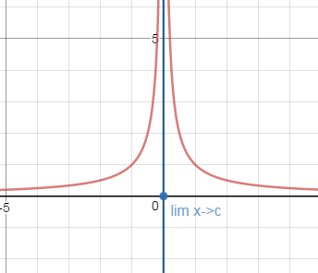

The intuitive idea of a limit hides within M. since M could be anything, including arbitrarily LARGE values, if one can algebraically show f(x) is always bigger than M, then you’ve gotten a vertical asymptote limit. Note

* that M doesn’t need to be > 0, it could be $∈R$, or bigger than 45, just let M be big.
  + It does simplify the math to state that M >0 though. Because when it will come to bounding, keeping M positive makes it easier.
* That there isn’t an f(x) – L, because that doesn’t make sense. We just use f(x). and work a M in the same way we work in an epsilon.
* That we choose the max of the delta’s if f(x) > M

For the opposite way $\left(\lim_{x→c}{f\left(x\right)=-∞}\right)$, simply:

1. M > 0 to M < 0
2. F(x) > M to f(x) < M

Now let’s work through an example. In this example I’ll include a one-sided limit for demonstration:

$$\lim_{x→2^{-}}{\frac{1}{x^{2}-4}= -∞}$$

*[Rough Work]*

$$=f\left(x\right)$$

$$=\frac{1}{(x-2)(x+2)}$$

At this point, we want to bound and replace by delta. Since we’re working with a one-sided limit, and with fractions, not linear equations, we must be careful with how we replace delta and the bound. To start, let’s look at the delta band:

$$x∈\left(2-δ, 2\right)$$

We can only work with one side of the delta band,

$$2-δ<x$$

$$-δ<x-2$$

$$\frac{1}{-δ}>\frac{1}{x-2}$$

Now we can replace $\frac{1}{x-2}$ with

$$>\frac{-1}{δ(x+2)}$$

Notice that the sign swapped. We’re working with a one-sided limit, so we only care what happens to the left when we bound.

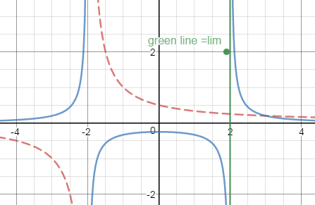

The blue line represents the original function, the red represents what we’re trying to bound, and the green represents the vertical asymptote

Looking at the graph, we see if $δ=1$ $→$ $x∈(1,2)$. The function remains injective, meaning picking the maximum value is easy, and nothing weird will go on. (ex. if we picked $δ=4→ x∈(-2,2)$, we’d fall into the same problem as addressed earlier with picking bad deltas[8] which result’s in a bad bound).

Now applying the math:

$$δ≤1$$

$$2-δ≤x$$

$$x∈\left(1,2\right)$$

$$2-1≤x$$

$$3≤x+2$$

$$\frac{1}{3} >\frac{1}{x+2}$$

$$\frac{1}{x+2} <\frac{1}{3}$$

No replace back into equation

$$>\frac{-1}{3δ}$$

Now set delta to be

$δ=\frac{-1}{3M}$

$$>\frac{1}{3\frac{-1}{3M}}=M$$

**

Now the 100% proof:

Let M <0 and delta = $\min\left\{1, \frac{-1}{3M}\right\}$

Let’s assume $0<\left|x-2\right|<δ$

$$=f\left(x\right)$$

$$=\frac{1}{(x-2)(x+2)}$$

By assumption

$$>\frac{-1}{δ(x+2)}$$

By * we get

$$>\frac{-1}{3δ}$$

By ** we get

$$>\frac{-1}{3\frac{1}{ 3M}}=M Q.E.D.$$

SOMETHING WENT WRONG SOMEWHERE. THE > SHOULD BE <.

## How to prove a horizontal asymptote limit

First, the formal definition:

We say that

$$\lim_{x→∞}{f\left(x\right)=L}$$

$$∀ϵ>0, ∃N>0 s.t. x>N ⇒\left|f\left(x\right)-L\right|<ϵ$$

For a graphical representation of a horizontal asymptote:

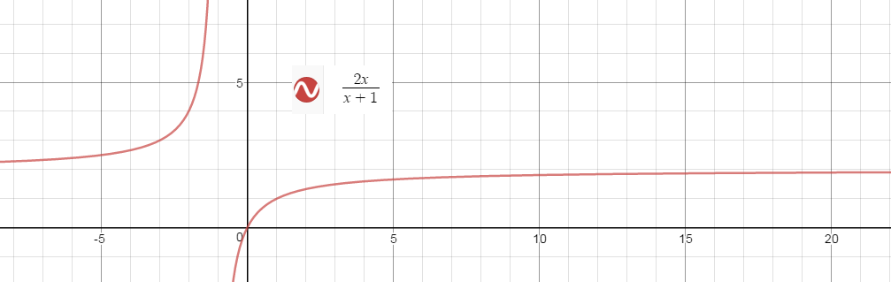The intuition here hides in N. Since epsilon could include points that are arbitrarily far away (like on the graph), and we could pick a point to represent N, we can always find an x that will be greater. Since any epsilon band has to work, arbitrarily small epsilon bands have to also work, which only work for converging functions. Note that technically, for any x you choose, you could always find an epsilon band that will break the definition. This seems to only work for epsilon and bands as the value of f(x) *intuitively* converges to L, as in no finite value will satisfy the definition so we define an intuitive grasp of the value of a function as x approaches infinity.

For the opposite way $\left(\lim_{x→-∞}{f\left(x\right)=L}\right)$, simply:

1. N > 0 to N < 0
2. x >N to x < N

Note:

* There isn’t a delta range anymore, so we no longer work towards a replicable delta. Instead
* When choosing the N, we choose the max of both values we chose if x > N

Now let’s work through an example:

$$\lim_{x→∞}{\frac{x}{x+1}=1}$$

*[Rough Work]*

$$=\left|f\left(x\right)-L\right|$$

$$=\left|\frac{x}{x+1}-1\right|$$

$$=\left|\frac{x}{x+1}-\frac{x+1}{x+1}\right|$$

$$=\left|\frac{-1}{x+1}\right|$$

$$=\left|\frac{1}{x+1}\right|$$

$$if 0<n<x then$$

$$=\left|\frac{1}{x+1}\right|<\left|\frac{1}{n+1}\right|$$

The sign reversed because it’s the reciprocal. CHECK. Note that since x is positive, the functions will always be positive:

$$\frac{1}{x+1}<\frac{1}{n+1}$$

Therefore, set $n=\frac{1-ϵ}{ϵ}$

To get a visual intuition, check:

<https://www.desmos.com/calculator/dvxugd7j8e>

Example: show that

$$\lim_{x→∞}{\frac{\sqrt{x}}{\sqrt{x+1}}}=1$$

HERE

## Proof a limit doesn’t exist:

Formally, this has to do with negating the definition of the limit:

$$¬\left(∃L, ∀ϵ>0, ∃ δ s.t. 0<\left|x-c\right|<δ⇒ \left|f\left(x\right)-L\right|<ϵ\right)$$

$$∀L, ∃ϵ>0, ∀δ s.t. 0<\left|x-c\right|<δ and \left|f\left(x\right)-L\right|≥ϵ$$

Look at predicate logic notes if this negation looks weird. Note that there was an L added at the beginning. This is implied in the regular definition since we only want one limit, but must be explicit here, since we want to show that no value of L can work.

From this, we could work our way through two proof that a limit doesn’t exist:

$$\lim_{x→0}{\cos\left(\frac{1}{x}\right) and \lim_{x→∞}{sin⁡(x)}}$$

We’re going to start with the first function. Graphically it looks like this:

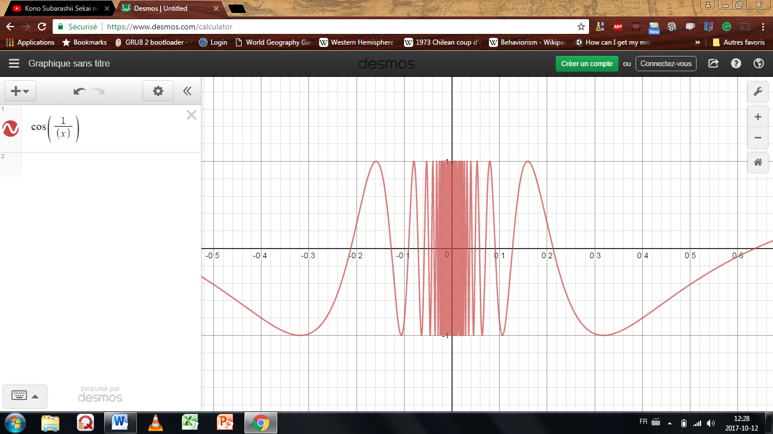  
This graph doesn’t have a limit as x approaches 0.

First, one must points out that this function is bounded. Thus $\left|f(x)\right|≤1$. This means we could get rid of all values of L beyond he bound. We only need to concentrate on the value between $-1<f\left(x\right)<1$. To simplify this even further, note that $-1<f\left(x\right)<0$ acts the same way as its positive counterpart, thus we only need to deal with $0<f\left(x\right)<1$ and the same properties will translate into the negatives. You are allowed to do all of this on your exam. Next; if there is a one sentence explanation that gives away way there isn’t a limit, then give it since it will make it clearer or the examiner. In this case, the 1+

The proof for the second function is similar:

$$\lim_{x→∞}{sin⁡(x)}$$

the function doesn’t converge as x gets arbitrarily large.

HERE

## Building of what we know – simplifying more complex limits with limit laws:

Now we’re starting to come back to regular limits. This section just indicates rules you already know:

$$suppose f,g \left(a,b\right)∈ R∧c∈R$$

$$\lim_{x→c}{f⁡(x)}=L$$

$$\lim_{x→c}{g⁡(x)}=M$$

$\lim_{x→c}{ αf⁡(x)}=αL$

Proof: $\left|f\left(x\right)-L\right|<\frac{ϵ}{\left|α\right|}$. This formula holds for delta. This means that:

$$\left|αf\left(x\right)-αL\right|<\frac{\left|α\right|ϵ}{\left|α\right|}=ϵ$$

$\lim_{x→c}\left(f\left(x\right)+g\left(x\right)\right)= \lim_{x→c}{f\left(x\right)}+\lim_{x→c}{g\left(x\right)}=L+M$

Proof:

If $0<\left|x-c\right|<δ_{1}⇒\left|f\left(x\right)-L\right|<\frac{ϵ}{2}$

And $0<\left|x-c\right|<δ_{2}⇒\left|g\left(x\right)-M\right|<\frac{ϵ}{2}$

Then let $δ=\min\left\{δ_{1},δ_{2}\right\}$ and $0<\left|x-c\right|<δ$ holds for both:

$$= \left|f\left(x\right)+g\left(x\right)-(L+M)\right|$$

$$≤\left|f\left(x\right)-L\right|+\left|g\left(x\right)-M\right|$$

$$<\frac{ϵ}{2}+\frac{ϵ}{2}$$

$$=ϵ$$

$\lim_{x→c}\left(f\left(x\right)-g\left(x\right)\right)= \lim_{x→c}{f(x)}-\lim_{x→c}{g\left(x\right)}=L-M$

$\lim_{x→c}\left(f\left(x\right)g\left(x\right)\right)= \underset{x→c}{(lim}{f(x)})(\lim_{x→c}{g\left(x\right)}= LM$

$\lim_{x→c}\left(\frac{f\left(x\right)}{g\left(x\right)}\right)=\frac{\lim_{x→c}{f(x)}}{\lim_{x→c}{g\left(x\right)}}=\frac{L}{M} if \lim_{x→c}{g\left(x\right)}≠0$

$\lim_{x→c}{\frac{1}{f\left(x\right)}}=\frac{1}{f\left(c\right)} , f\left(c\right)≠0$

However, you need to prove these laws and be weary of a couple of traps. The main trap to avoid is if a limit doesn’t exist, using the limit laws will not work. Ex:

$$= \lim_{x→0}{x\sin\left(\frac{1}{x}\right)}$$

$$= \lim_{x→0}{x}∙\lim_{x→0}{\sin\left(\frac{1}{x}\right)←limit does not exist}$$

Another example:

$$= \lim_{x→1}\left(\frac{x}{x-1}-\frac{1}{x-1}\right)$$

$$= \lim_{x→1}\left(\frac{x}{x-1}\right)- \lim_{x→1}{\frac{1}{x-1}←limit does not exist}$$

In both cases, the limit laws cannot be applied[9]

## Continuity and discontinuity

$$\lim_{x→c}{f\left(x\right)}=f(c)$$

Comparing the epsilon-delta equation for proving a limit and continuity:

Limit: $∀ϵ>0, ∃ δ s.t. 0<\left|x-c\right|<δ → \left|f\left(x\right)-L\right|<ϵ$

Cont: $∀ϵ>0, ∃ δ s.t. 0<\left|x-c\right|<δ → \left|f\left(x\right)-f(c)\right|<ϵ$

At this point, it should be clear why this is true (Ask Tyler to proof some things with this)

(we’ve proven polynomial, sine cosine, and other functions are continuous)

### Uniform continuity (for MAT157)

This is not needed for MAT137, but will be mentioned for those who are curious:

$$∀ϵ>0, ∃ δ s.t. 0<\left|x-y\right|<δ → \left|f\left(x\right)-f(y)\right|<ϵ$$

Intuitively, this means that if a function grows to quickly (like 1/x near 0), it is not uniformly continuous. This concept is useful for a few theorems.

## Side note

Question for the prof: in one of the CRA questions, there was a quadratic equation. The question was how many roots there are (not specifying real numbers). There was two wrong answer: one root and three roots. Because of the fundamental theorem of algebra, it must have two roots.

Why does

$$-5<x-7<1$$

go to

$$\left|x-7\right|≥0?$$

Also,

$$9< x+5<11$$

$$\left|x+5\right|<11?$$

In the one sided limit section, why can’t I solve it the conventional way taught in class?

Is there anything else I need to restrict for one sided limits. at page 181, you restrict x < 0. Do I need to write that on the test?

Can you *try* to explain $dy=2xdx$ I did some advanced math a little while back and I wonder if I could get it.

p.187, a few of them.

proof the limit for any sin, cos, tan, or other trigs?

p.191 do we neeed to proof the uniqueness of the limit?

Do we need to be able to prove all the limit laws?

How can we prove continuity on an interval?

p.224 overlined

Personal note:

* review P.41 p.58 overlined,

1. (a big one for visual clarity)
2. When doing the math, there won’t be a problem on choosing a wrong delta band, since we’ll make an equation were choosing any epsilon band will produce the correct delta band (assuming the limit exists).
3. You could actually start with x-c, but in every excercice they gave so far, they started with f(x) – L.
4. Remember, it could be what we want but it has to follow the definition, as explained in the paragraph above.
5. Again, we can for now just replace this value with delta because the function for delta is linear and never does anything weird. However, it will not be so trivial later. Shown in the hard limit proof
6. If you’re skeptical, try making an epsilon band that fits that delta band. It won’t work.
7. If the limit exists, we need to choose a delta range that is the smaller of 1 and $\frac{ϵ}{11}$. This is because we assumed delta to be 1 to find epsilon/11. It will always come out to be the epsilon if you’ve done it correctly. Also, because of the definition of a limit (and assuming the limit exists), if one delta band works, a smaller one will also work.
8. Quesiton : wouldn’t picking (-2,2) be ok in this scenario, since it’s an open interval?
9. Use the squeeze theorem to solve this problem.